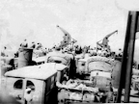
Harold Avent along with the 11th Evacuation Hospital departed Bizerte July 13, 1943 on board LST 357.
By July 15, it opened northwest of Licata, while the 10th Field Hospital operated in town.
As local hospital facilities were inadequate, Seventh US Army and II Corps were called upon to help, yet in the landing phase and during the following days medical supplies and beds could be spared to treat emergency cases only. Lt. Colonel Matthew C. Pugsley, MC (3d Infantry Division) was the “Joss Force” Surgeon. The 10th Field Hospital, one Platoon of the 11th Field Hospital and the 11th Evacuation Hospital were to provide medical support to the three US Divisions serving under Maj. General Geoffrey Keyes.
The organization moved from Licata July 21, up to Agrigento, approximately sixty or more miles to the rear. Medical units including Field and Evacuation Hospitals followed closely behind combat forces, and were sometimes ahead of the Clearing Stations. A concentration was built up in the vicinity of Nicosia, five to fifteen miles behind the Troina front, grouping the 15th Evacuation, the 11th Field, and the 11th Evacuation Hospitals. Leapfrogging continued with Platoons of the 11th Field advancing toward Cesaro and Randazzo.
When fighting in Sicily and more particularly over roadless mountains, some difficulties were experienced with evacuation of the wounded. As litter bearers were the only means to bring the casualties to the various Aid Stations, mules were either requisitioned or purchased from local farmers to carry litters (as had been done in Tunisia). The 9th Infantry Division Veterinary Officer and his assistants handled care and management of the animals. Due to road demolitions or lack of roads, and long litter hauls (sometimes close to 7 hours) well organized with necessary relays and stationed at intervals; it became possible to evacuate casualties from precarious positions in mountainous terrain. Slightly wounded men were often evacuated sitting on pack mules, while the more severe cases were carried by tandem or singles mules, or brought down by enemy PW details. Horses and pack animals suffered with quite a few animals becoming battle casualties. Lines of evacuation fluctuated with the progress of the campaign. Until late July of 1943, ambulances and trucks carried the bulk of the casualties to either the 93d Evacuation Hospital (activated as 61st Surg Hosp 1 Jun 41, redesignated 93d Evac Hosp 25 Aug 42, embarked 16 Apr 43 for N. Africa), serving II Corps at Gela, or the 11th Evacuation Hospital at Licata, and later at Agrigento, serving the Provisional Corps. After capture of Palermo, the city became the focal point for medical evacuation to North Africa, which took place by Hospital Carriers or by LSTs. After July 14, primitive and occasional air evacuation was begun from airfields around Gela and Licata. The 802d Medical Air Evacuation Transport Squadron took over operations from July 16 onward, initially flying out of Agrigento, later out of Castelvetrano, and finally out of Palermo. Such flights were provided with a Flight Nurse and a Medical Technician to accompany the patients during their evacuation. Sea evacuation was handled by two American (USAHS “Acadia” and USAHS “Seminole”) and three British Hospital Ships assisted by five British Hospital Carriers (5,967 men were evacuated by air and another 5,391 by sea from Sicily). At the time, 4 Officers, 60 Nurses, and 88 Enlistee Men were serving on Sicily.
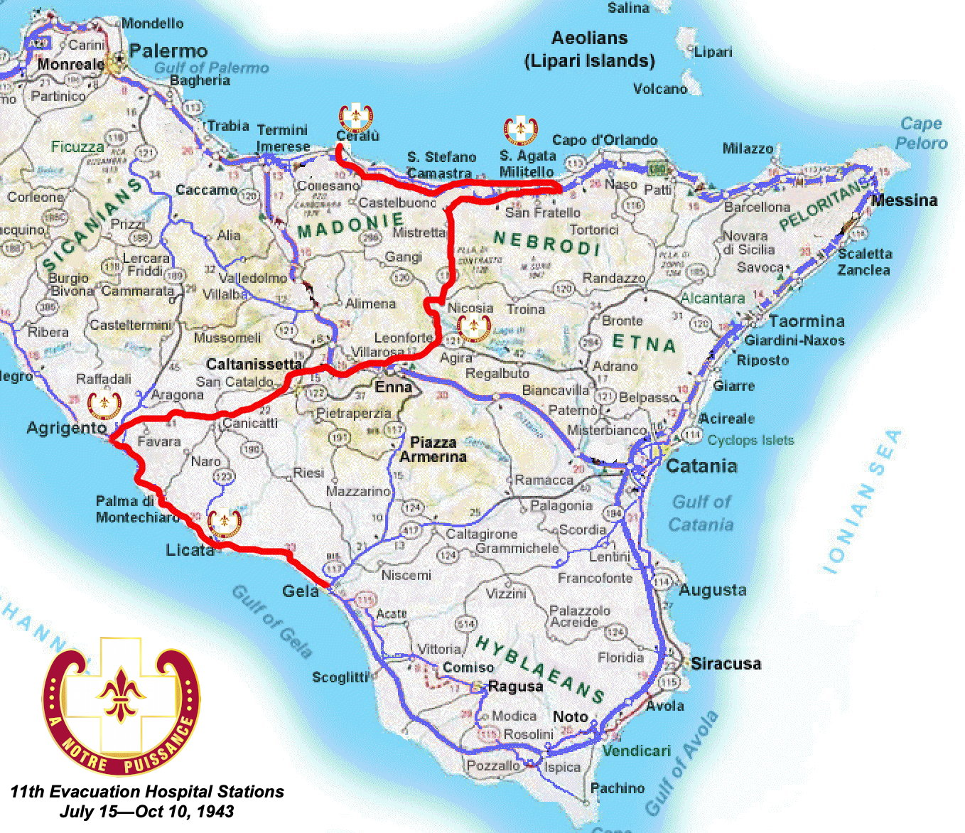
It should be noted that although the medical personnel were supposed to follow the advancing infantry, they sometimes beat them. This resulted in Nurses digging foxholes while being bombed, and surviving on rations with no water except in their canteens, and temporarily sleeping in pup tents, until their equipment and friendly forces caught up with them.
Stations – 11th Evacuation Hospital
- Licata – July 15, 1943 July 22, 1943
- Agrigento – July 22, 1943 August 5, 1943
- Nicosia – August 6, 1943 August 13, 1943
- Santa Agatha – August 13, 1943 August 21, 1943
- Cefalu – August 21, 1943 October 10, 1943
Harold received orders to transfer from the 11th Evac in Palermo, Sicily, to the 4th Surgical Team in Birzerte, Tunisia.

